Ron’s notes
November 12, 2018

Seligman article

Cultural neuroscience
problems with the area’s conception of culture
“challenging the ontological primacy of the brain in investigating and understanding the mind” (p.13, p.17 of 35)
Cultural influence on brain (epigenetics metaphor, encultured brains)

Terminology
How we operationalize culture
Cultural validity, ecological validity
Essentialism, essentialize
Embodied, embodiment of culture
Situated brain
Enacted, enactments
Biological reductionism
fMRI
Priming (with flags, for example)
Looping, cultural systems as dynamic and interactive, role of brain

Where is culture? Mind, Environment; beliefs, practices
“dynamic systems of social action and regulation” (p. 11 of 35)
In a situation, cultural scripts influence our attention and information processing, which influence our felt experience and behaviour, which influences our situation, which …

Note connections to Gjerde’s notion of a personal cultural psychology, agency
“how people respond to, engage with, incorporate, resist, and manipulate cultural materials” (p.10, p.12 of 35)
Use of tools

Criticism of the emphasis in cultural psychology on the East/West dichotomy
Difference is not the main point, emphasis on cultural process
Do Seligman criticisms apply to the authors we have read?

Dissociation phenomenon
Relate to Adams
Role of the brain in dissociation and other psychological phenomena

Interaction of culture with poverty, inequality, social exclusion
Relate to Hanley and others on class
How we experience grief, anger, volition
Ecocentric experience of self – spirits and the land
Consider what Bhatia & Priya might contribute to analysis of indigenous condition
Transgenerational effects of disruptions to a culture’s community relationship structures
Demoralization

Conclusions
“culture as systems of meaning and practice engaged by individuals with identifiable goals, strategies, and constraints”
“a mismatch between cultural knowledge and behavior can negatively affect health via stress pathways” (p. 13 of 35)

Markus chapter

Known for an early paper with Kitayama on east-west culture differences

This book chapter cycles back and forth from east to west, interdependent selves to independent selves. She pretty clearly favours promoting cultural change in the direction of blending east and west. Is it the same kind of blending seen In Durkin? Tolerance or adaptation?

The culture cycle: Big ideas – Institutions – Interactions – I’s (selves)

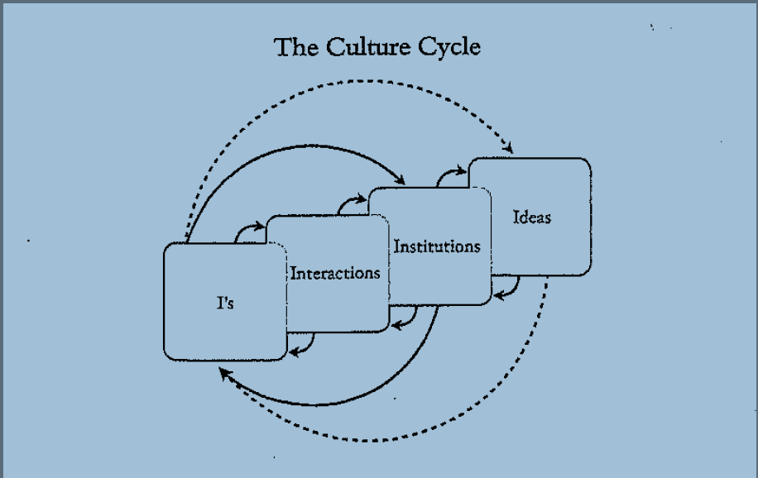

Compare with Figure 1.1 in Seligman.

Begins with examples of parent-child interactions in context of independence/interdependence

Big idea: what a person is and should be
Nature of self
Independence, interdependence

Institutions: Churches, schools, government agencies, …
Working for a more harmonious world

Interactions: among one another, in context of institutions, associated customs/artifacts

Selves: children

Look for examples in each of these sections:
Interactions that promote independence, interactions that promote interdependence
Standing out, fitting in
Media portrayals of individuality, media portrayals of community
Attributions for accomplishment: Self, Team (Greenfield’s volleyballers)
Selling oneself, smiling
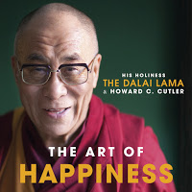

Origins of the independent and interdependent world views
Greek atomism
Confucian harmony through respect for obligations and responsibilities
Particles and context

Some blending suggestions for education

Carol Dweck’s Mindsets and Angela Duckworth’s Grit
Individualist or communal?

Speaking in class example

Bamboo ceiling
Stereotype threat reference

For a personal reflection on the lived experience of a Chinese-American-Canadian
Wesley Yang, The Souls of Yellow Folk: Essays
New York Magazine article, Paper Tiger

